🏗️ Class 2: Reshaping (Array-vai Matrix-a mathurathu)
Namma munnadi ezhuthiya [3000, 4000, 5000] oru "Flat Array" (Ore oru line-la irukkura list). Aana, namma database-la irukkura maari, idhai oru Table (Matrix) maari matha mudiyum.
Python
import numpy as np

# Namma kitta 6 salary data irukkunnu vechukonga
salary_data = np.array([3000, 4000, 5000, 6000, 7000, 8000])

# Ippo idhai 2 row, 3 column ulla table-a (Matrix) mathalam
matrix = salary_data.reshape(2, 3)

print("Original Array:")
print(salary_data)
print("\nReshaped Matrix (2x3):")
print(matrix)
🔍 Line-by-Line Breakdown:
- salary_data = np.array([3000, 4000, 5000, 6000, 7000, 8000]):
  - 6 values irukkura oru array.
- salary_data.reshape(2, 3):
  - Meaning: "En kitta irukkura 6 values-ai, 2 row-a, 3 column-a pirichu kodu" nu computer-kku command kodukrom.
  - Condition: 2 * 3 = 6. Namma kodukra row and column-oda total count, original data count-oda match aaganum!
- Matrix Concept:
  - Ithu dhaan namma MySQL table maari structure-a maathurathu.
💡 Teacher's Note:
Neenga reshape(3, 2) nu kudutha, 3 row, 2 column-a maathidum. Indha Reshaping skills irundha dhaan, neenga data-vai neenga virumbura maari "Arrange" panna mudiyum.
Idhu purinjidha Irshad? Code-ai run panni paarunga. Output-la 2 row, 3 column-la value vandha udane, "Reshaping Success" nu sollunga! Adutha step-la namma "Statistical Functions" (Mean, Median) pathi pesuvom. Ready-a?
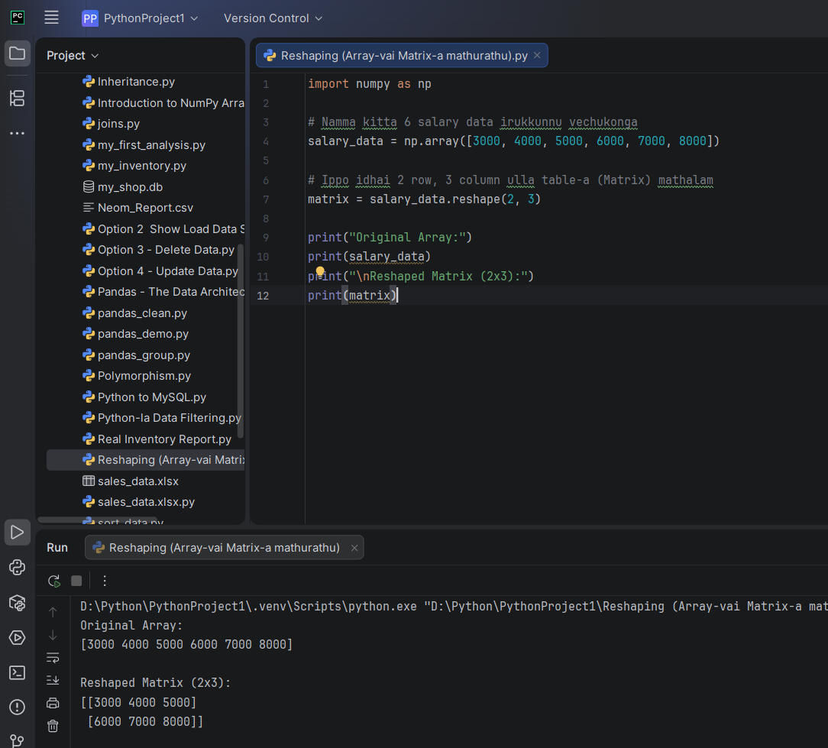
print("\nReshaped Matrix (2x3):") aama teacher sinna sandegam neega enn \n endu kudthiringa ada thelivu paduthunga
Semma Irshad! Output-ai paarthen, 2 row, 3 column-a correct-a form aagirukku. "Reshaping Success!"
Ippo unga sandegam: \n enna vishayam?
💡 What is \n?
Intha \n symbol-ai "Newline Character" nu solluvom.
- \ (Backslash): Ithu oru "Control Character". Computer-kku "Next varra letter-ai literal-a print pannama, vera ethavathu oru special velai sei" nu sollum.
- n: Stands for New line.
Simple-a sonna: Neenga \n nu kodutha, computer adutha vari-kku (next line-kku) kudhichu print pannum.
🔍 Practical Example:
Python
print("Hello")
print("World")
# Output:
# Hello
# World

print("Hello\nWorld")
# Output:
# Hello
# World
Indha code-la:
- print("\nReshaped Matrix (2x3):")
- Inga \n kuduthadhunaala, output-la "Reshaped Matrix..." print aagurathukku munnadi oru "empty line" (gap) varum. Ithu paarkka nalla, neat-a (formatting) irukkum.

